ISM 6205 First Project Fall 2019

For each question, write a SQL query that will provide the given answer. Use the database NursingHome_Medium.

1. List providers in the same city that have certified bed capacity that differs by more than 250. The lesser bed capacity should be greater than 100.

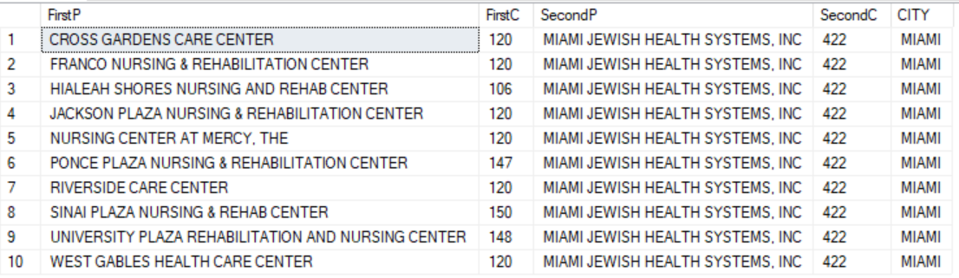

select

p1.PROVNAME as FirstP,

p1.BEDCERT as FirstC,

p2.PROVNAME as SecondP,

p2.BEDCERT as SecondC,

p2.CITY

from

BM_ProviderInfo p1,

BM_ProviderInfo p2

where

p1.CITY = p2.CITY

and (p2.BEDCERT - p1.BEDCERT > 250)

and( p1.BEDCERT > 100)

order by

FirstP ;

2. List providers in Broward county that have the maximum certified bed capacity in each city. The certified bed capacity should be greater than 150. Employ a “With” clause. Order by provider number.

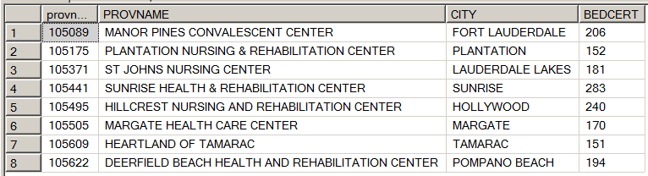

with MR as

(

select

provnum,

PROVNAME,

CITY,

BEDCERT,

COUNTY_NAME,

max (BEDCERT) over (partition by city) as MQ

from

BM_ProviderInfo

)

select

provnum,

PROVNAME,

CITY,

BEDCERT

from

MR

where

BEDCERT = MQ

and (MQ > 150)

and (COUNTY_NAME = 'broward')

order by

provnum ;

3. List providers who have a complaint count that is at least 4 times greater than the average for their city. Use the cast command to round the average to 2 decimals. Sort by provider number. You may optionally employ the With clause.

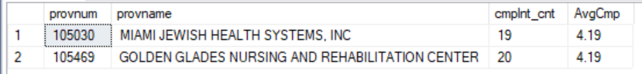

with MR as

(

select

provnum,

PROVNAME,

CITY,

cmplnt_cnt,

cast(avg(cast(cmplnt_cnt as decimal (3,0))) over (partition by city) as decimal (3,2)) as AvgC

from

BM_ProviderInfo

)

select

provnum,

PROVNAME,

cmplnt_cnt,

AvgC

from

MR

where

cmplnt_cnt > 4*AvgC

order by

provnum ;

4. List providers that have been tagged with deficiency 0015 as well as 0025.



select

provnum,

Provname

from

[dbo].[BM_Deficiency]

where

tag = '0015'

intersect

select

provnum,

Provname

from

[dbo].[BM_Deficiency]

where

tag = '0025' ;

5. List providers who do not have a deficiency prior to the survey output date 2014-01-01. In other words, all their deficiencies occurred after the date 2014-01-01.



select

provnum,

PROVNAME

from

BM_ProviderInfo

where

provnum not in

(

select

provnum

from

BM_Deficiency

where

survey_date_output < '2014-01-01'

) ;